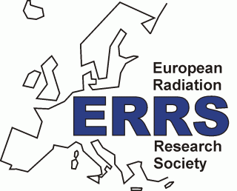
EUROPEAN RADIATION RESEARCH SOCIETY
Young Investigator Award 2020
Application Form
Deadline for application is June 15, 2020 (8pm)
at err_secretariat@sckcen.be

Eligibility criteria:
- ≤ 35 years of age
- if PhD: ≤ 3 years of postdoctoral experience
All applicants must submit:
- abstract(s) of the work to be presented at the ERRS2020 conference, Lund, September 2020;
- supporting letter from their supervisor(s) or head of laboratory/department;
- a short curriculum vitae (max. 1 page);
- a completed application form.
- All files to submit to the ERRS secretariat: err_secretariat@sckcen.be

Personal information
Last name:
First name:
Title (Prof, PhD, MSc, MD, BSc,…):
Gender
Date of birth ( & age):
Nationality & place of residence:
Current affiliation (laboratory, institute/university, city, country):
Current position: (Undergraduate/Graduate, PhD student, Postdoc, other (specify))
Phone number(s):
E-mail address:
Bank account (IBAN & SWIFT codes):

Cont. next page
Education
Highest degree obtained
(BSc, MSc, PhD, MD):
Year:
Awarding university/institution:
Field:
(e.g. Biology, Chemistry, Radiation Biology, Medical Physics, Physics, etc.)

Professional/academic experience
Professional experience record (max. 5 lines):

Technical competences and expertise domains (max. 5 lines):

Further qualifications, if necessary (max. 5 lines):

Publications
Published and accepted papers in international peer-reviewed journals: review papers/research papers/others Provide references (authors, title, journal, year, volume, pages)

Conference abstracts/proceedings, etc.
Report title, type (invited/oral/poster), reference (if applicable) name, place and year of conference

